**Topic A: Cultural Colonialism and restitution of heritage assets**

UNESCO

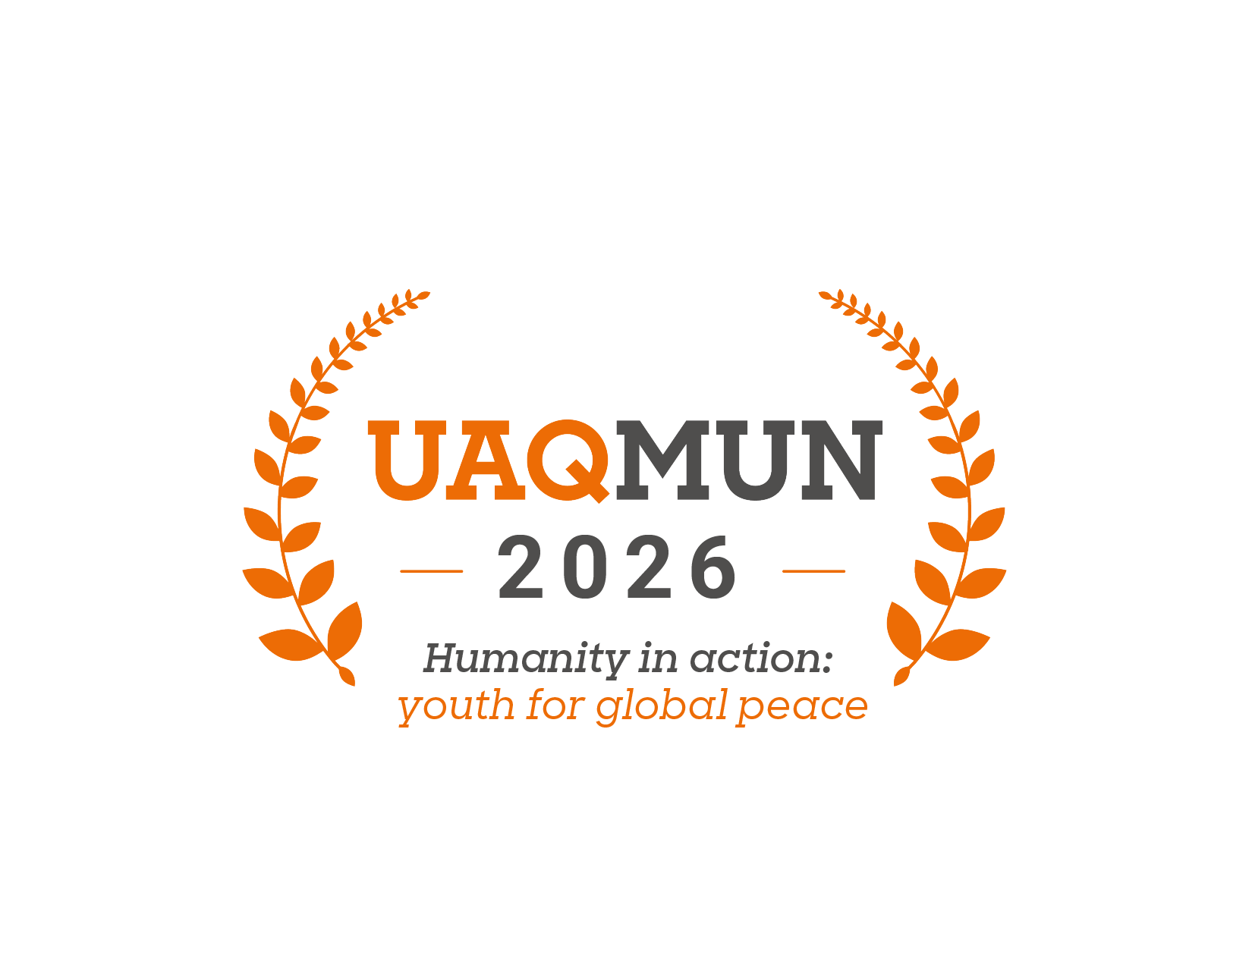

## **Introduction**

We are pleased to welcome you to this edition of the Anáhuac Querétaro University Model United Nations (UAQMUN 2026). The School of International Relations and the organizing team sincerely appreciate your participation and wish you a formative, challenging, and enriching experience within this model.

The United Nations Educational, Scientific, and Cultural Organization (UNESCO) serves as the preeminent international body dedicated to promoting cultural and scientific exchange. Its mandate naturally positions it as the principal venue for discussing the multifaceted issues of cultural property, which are often inextricably linked to education, historical preservation, and human rights, where delegates discuss and negotiate the main multilateral issues related to culture and heritage (Dorau, 2021).

On this occasion, the committee will focus on the debate surrounding the topic:

***“Cultural Colonialism and the Restitution of Heritage Assets”***

The demand for the repatriation of these assets has transformed from a fringe issue into a central point of diplomatic contention between former colonial powers and the nations from which these objects originated. Increasingly, these claims are no longer framed solely as cultural matters but as questions of sovereignty, legitimacy, and the moral responsibility of institutions to confront their colonial pasts. As a result, the issue has gained prominence in international forums, forcing governments, museums, and cultural organizations to reconsider long-standing narratives about who has the right to preserve, interpret, and display these artifacts.

Therefore, this committee invites delegates to rigorously examine the historical context, legal frameworks, and ethical arguments surrounding this debate. This document provides a general overview that facilitates a foundational understanding of the antecedents, dynamics, and consequences of this episode.

However, it is expected that each representative will contribute a thorough research work that allows for a consistent reflection on the position of each State, thereby opening a space for reflection on the challenges of global cultural stewardship.

Finally, we reiterate our recognition to each of the delegates for accepting the challenge of undertaking this exercise of dialogue and cooperation. We hope that this United Nations Model is not only an academic space, but an opportunity to understand the significance of using negotiation to make this world a better place.

**Topic “A”: Cultural Colonialism and the Restitution of Heritage Assets**

The central conflict of this debate pits two opposing theories against one another. The first is Cultural Nationalism, which posits that a people’s cultural heritage is an essential part of their national identity and, therefore, should reside within their country of origin. This position is supported by the principle of cultural self-determination, which affirms the right of communities to preserve and mandate their heritage to maintain and develop their identity (Caligiuri, 2024).

The second is Cultural Internationalism, often embodied in the Universal Museum concept. This theory argues that cultural property is not tethered to one nation but belongs to all of humanity. Major encyclopedic museums, such as the British Museum or the Louvre, justify their retention of artifacts by arguing they are the best custodians, capable of providing primary preservation, scholarly access, and cross-cultural education to a global audience (Antiquity, 2015). The 2002 “Declaration on the Importance and Value of Universal Museums,” signed by many leading institutions, is a key document for this position, arguing that these museums serve as “agents in the development of culture” and that their collections have become part of the heritage of their host nations (Dorau, 2021).

***Importance***

The discourse surrounding restitution is far from a niche academic pursuit; it is a profound negotiation of historical truth, cultural identity, and global justice. The debate extends far beyond the physical location of an object and touches upon the foundational themes of a post-colonial world.

Firstly, this discussion is essential for historical justice and decolonization. The demand for restitution is a fundamental aspect of a former colony reclaiming a pre-colonial identity (Dorau, 2021). Many artifacts were acquired under circumstances of war, exploitation, or outright looting, and their return is seen as a means of correcting these historical wrongs. A powerful example is the 2018 return of human remains from Germany to Namibia, which were gruesome relics of what has been called the twentieth century’s first genocide. This act of repatriation acknowledges the violent context of the past and serves as a form of healing (Gilchrist, 2025).

Secondly, the debate highlights the deep-seated connections between cultural identity and spiritual value. For many communities, cultural objects are not merely works of art to be admired in a museum but are imbued with profound religious or spiritual significance. The Benin Bronzes, for instance, are considered “physical manifestations of the spirits of generations of Edo ancestors,” vital for ongoing religious practices (Gilchrist, 2025). Similarly, the people of Rapa Nui have sought the return of a moai statue from a foreign museum, as they believe it contains the spirit of an ancestor who can no longer protect his descendants from afar (Siame, 2024). The displacement of these objects fundamentally alters their meaning and purpose, transforming sacred symbols into decontextualized curiosities.

Ultimately, this discussion forces both claimants and holding institutions to confront their histories and move towards a new global ethos. It challenges the paternalistic arguments that once justified the retention of artifacts in Western museums and instead promotes a dialogue built on mutual respect and shared responsibility (Petersen, 2019). The debate is a catalyst for a more honest narrative in art history and a critical examination of the very purpose of museums in a decolonized world.

***Antecedents***

The practice of cultural plunder is an ancient one, with precedents dating back to the Roman Empire and the widespread looting carried out during the Napoleonic Wars. However, the scale and systematic nature of the appropriation during the European Colonial period distinguish it from earlier acts of wartime looting (Dorau, 2021).

The evolution of international law on this matter reflects a growing, though often slow, global impact. Before the 1970s, there was no comprehensive international framework to govern the trade and transfer of cultural property. An early limit for restitution was established at the Congress of Vienna in 1818, which led to the return of artifacts plundered during the Napoleonic Wars (Caligiuri, 2024).

A major turning point came with the 1970 UNESCO Convention on the Means of Prohibiting and Preventing the Illicit Import, Export, and Transfer of Ownership of Cultural Property. This treaty was the first international legal instrument to combat the illicit trade of cultural items. It established a framework for preventing illicit import and export, calling for states to enforce preventive measures, create restitution provisions, and foster international cooperation (UNESCO, 2021).

The complexity of the restitution debate is best understood through the analysis of specific cases, each representing a unique set of challenges and arguments:

1. The Parthenon Marbles: A Dispute of “Reunification”

The dispute over the Parthenon Marbles, also known as the Elgin Marbles, is perhaps the most famous repatriation controversy. Between 1801 and 1809, Lord Elgin removed a significant portion of the sculptures from the Parthenon in Athens, claiming to have received a firman from the Ottoman authorities (Guerra, 2025). The British government purchased the sculptures from him in 1816, and they have been housed in the British Museum ever since.

The British Museum’s primary arguments for retention are centered on the legality of the acquisition, the concept of the universal museum, and its capacity for preservation. The museum asserts the marbles were legally obtained and that housing them in London provides access to a global audience (Guerra, 2025).

Greece, however, has strategically reframed the debate. The country's demand for return is not framed as a legal claim of ownership but as a moral claim for the reunification of a single monument. As the Greek Prime Minister stated, holding the sculptures in two separate locations is “like cutting Mona Lisa in half”. This strategic move bypasses the British Museum’s legal defenses, specifically the 1963 Act, and instead engages with a powerful moral argument (Scott, 2023).

1. The Benin Bronzes: A Case for Corrective Justice

The Benin Bronzes are a collection of thousands of artifacts looted by British forces during a violent and premeditated “punitive expedition” in 1897. This case is viewed as a clear-cut example of corrective justice, where the violent and unethical nature of their acquisition serves as a central argument for their return. For the Edo people of Nigeria, the bronzes are not mere art objects but hold profound spiritual and cultural significance; their removal would prevent the community from performing essential religious practices (Gilchrist, 2025).

In recent years, the moral momentum in favor of repatriation has led to a significant shift in institutional behavior. Museums across Europe and the United States have begun to make significant returns, with the Netherlands, Germany, and the Smithsonian Institution leading the way (Akers, 2025). These repatriations have occurred despite the lack of a favorable international legal framework for colonial-era claims, demonstrating that widespread moral pressure and public awareness can drive meaningful change. The Nigerian government has also streamlined future efforts by officially recognizing the Oba of Benin’s rights to the artifacts, ensuring a more direct process (Cascone, 2025). This case illustrates that the “universal museum” concept is being actively challenged and redefined by a new institution ethos, one that values historical accountability over collection size.

1. The Rosetta Stone: A Unique Intellectual Debate

The debate surrounding the Rosetta Stone is unique, as it is centered on a different type of value. The Stone was discovered by French soldiers in Egypt in 1799 and was later transferred to the British under the terms of the Treaty of Alexandria in 1801. The British Museum’s argument for retaining the artifact is not rooted in a violent colonial act, but rather in the claim that it was acquired legally from a defeated army. Proponents for retention also argue that the Stone's value is primarily intellectual; it is the key that unlocked the understanding of Egyptian hieroglyphics and is thus a crucial artifact for the history of archaeology and the intellectual development of all humanity (British Museum, 2017).

This position presents a powerful counterpoint to the moral claims of the Benin Bronzes, as it forces delegates to consider whether all heritage assets are equal. Should a religious artifact that is vital to a living culture have a stronger claim to repatriation than a purely intellectual one that serves as a tool for cross-cultural understanding?

**Guiding questions**

1. To what extent can the “universal museum” concept be reconciled with the principles of cultural self-determination and corrective justice?

2. How should international legal frameworks, such as the 1970 UNESCO Convention, be reformed to address the specific complexities of colonial-era acquisitions?

3. What role should public opinion and digital repatriation play in overcoming legal and political obstacles to restitution?

4. Beyond legal and political action, how can holding institutions and claimant nations build partnerships that foster cultural exchange and mutual respect?

5. Is it a state’s right or a moral obligation for a nation to repatriate objects, and what factors should be prioritized when a claim is made (historical violence, cultural significance, or the ability to preserve the object)?

6. How can the UNESCO ICPRCP be strengthened to move beyond a purely advisory role and become a more effective body for dispute resolution?

7. How does the "universal museum” concept address the spiritual and cultural significance of objects that were never intended for public display, such as the Rapa Nui moai or the Benin Bronzes, which are vital to living communities?

8. Should the capacity of a claimant nation to preserve and display artifacts be a determining factor in a repatriation claim, or should international bodies be mandated to assist in building this capacity?

9. How can the legal and ethical frameworks for restitution evolve to address artifacts acquired through non-violent means, such as the Rosetta Stone, which is valued for its intellectual contribution to humanity?

10. What role should public opinion and the rise of digital repatriation play in challenging domestic laws, such as the British Museum Act of 1963, that currently impede restitution efforts?

**Member States**

1. Nigeria
2. Benin
3. Egypt
4. Namibia
5. Greece
6. Cambodia
7. Zambia
8. China
9. Mexico
10. Peru
11. Ukraine
12. India
13. Pakistan
14. Iraq
15. United Kingdom
16. United States
17. Canada
18. Sweden
19. Austria
20. Japan
21. Belgium
22. Switzerland
23. Spain
24. Germany
25. Netherlands
26. France
27. Brazil
28. Argentina
29. Italy
30. South Korea

**References**

Akers, T. (2025). *MFA Boston returns two works to Kingdom of Benin*. *The Art Newspaper*. [https://www.theartnewspaper.com/2025/07/02/museum-fine-arts-boston-restitutes-benin-bronzes-nigeria](https://www.theartnewspaper.com/2025/07/02/museum-fine-arts-boston-restitutes-benin-bronzes-nigeria?utm_source=chatgpt.com)

Antiquity. (2015). *To Repatriate or Not to Repatriate, That is the Question…. James Cuno’s Case Against Repatriating Museum Artifacts*. AntiquityNOW. [https://antiquitynow.org/2015/02/10/to-repatriate-or-not-to-repatriate-that-is-the-question-james-cunos-case-against-repatriating-museum-artifacts/](https://antiquitynow.org/2015/02/10/to-repatriate-or-not-to-repatriate-that-is-the-question-james-cunos-case-against-repatriating-museum-artifacts/?utm_source=chatgpt.com)

British Museum. (2017). *Everything you ever wanted to know about the Rosetta Stone*.[https://www.britishmuseum.org/blog/everything-you-ever-wanted-know-about-rosetta-stone](https://www.britishmuseum.org/blog/everything-you-ever-wanted-know-about-rosetta-stone?utm_source=chatgpt.com)

Caligiuri, A. (2024). *Legal aspects concerning the restitution of cultural property removed during colonial occupation*. QIL: Revista de Derecho Internacional (QIL-QDI). [https://www.qil-qdi.org/legal-aspects-concerning-the-restitution-of-cultural-property-removed-during-colonial-occupation/](https://www.qil-qdi.org/legal-aspects-concerning-the-restitution-of-cultural-property-removed-during-colonial-occupation/?utm_source=chatgpt.com)[qil-qdi.org](http://qil-qdi.org)

Cascone, S. (2025). *Why the Benin Bronzes Are Being Returned—and Who Gets Them*. Artnet News. [https://news.artnet.com/art-world/mfa-boston-benin-bronzes-restitution-2662790](https://news.artnet.com/art-world/mfa-boston-benin-bronzes-restitution-2662790?utm_source=chatgpt.com)

Dorau, B. G. (2021). *Repatriation of cultural artifacts: Overview*. Research Starters. EBSCO. [https://www.ebsco.com/research-starters/anthropology/repatriation-cultural-artifacts-overview](https://www.ebsco.com/research-starters/anthropology/repatriation-cultural-artifacts-overview?utm_source=chatgpt.com)

Gilchrist, F. (2025). *Repatriating the Benin Bronzes: The Controversy Behind the British Museum*. *Retrospect Journal*. [https://retrospectjournal.com/2025/03/09/repatriating-the-benin-bronzes-the-controversy-behind-the-british-museum/](https://retrospectjournal.com/2025/03/09/repatriating-the-benin-bronzes-the-controversy-behind-the-british-museum/?utm_source=chatgpt.com) [Retrospect Journal](https://retrospectjournal.com/2025/03/09/repatriating-the-benin-bronzes-the-controversy-behind-the-british-museum/)

Guerra, N. (2025). *Student Spotlight: Rectifying History – The Case for Returning the Parthenon Marbles*. *History at BGSU*. [https://blogs.bgsu.edu/history/2025/07/student-spotlight-rectifying-history-the-case-for-returning-the-parthenon-marbles/](https://blogs.bgsu.edu/history/2025/07/student-spotlight-rectifying-history-the-case-for-returning-the-parthenon-marbles/?utm_source=chatgpt.com)

Petersen, K. L. (2019). *Should we defend the universal museum?* *Museum Studies Blog at Tufts University*.<https://sites.tufts.edu/museumstudents/2019/02/20/should-we-defend-the-universal-museum/>

Scott, E. (2023). *Elgin Marbles: UK government assessment of loaning the sculptures to Greece*. *House of Lords Library – In Focus*. [https://lordslibrary.parliament.uk/elgin-marbles-uk-government-assessment-of-loaning-the-sculptures-to-greece/](https://lordslibrary.parliament.uk/elgin-marbles-uk-government-assessment-of-loaning-the-sculptures-to-greece/?utm_source=chatgpt.com)

Siame, M. (2024). *Cultural Repatriation: A Long Way From Home*. *Nkwazi Magazine – Interactive*.<https://interactive.nkwazimagazine.com/cultural-repatriation-a-long-way-from-home/>

UNESCO. (2021). *Fight illicit trafficking (1970 Convention)*. UNESCO.<https://www.unesco.org/en/fight-illicit-trafficking>