**Topic B: The Global Weaponization of Energy: Sanctions, Pipelines, and the Use of Oil and Gas as Tools of War**

SECURITY COUNCIL

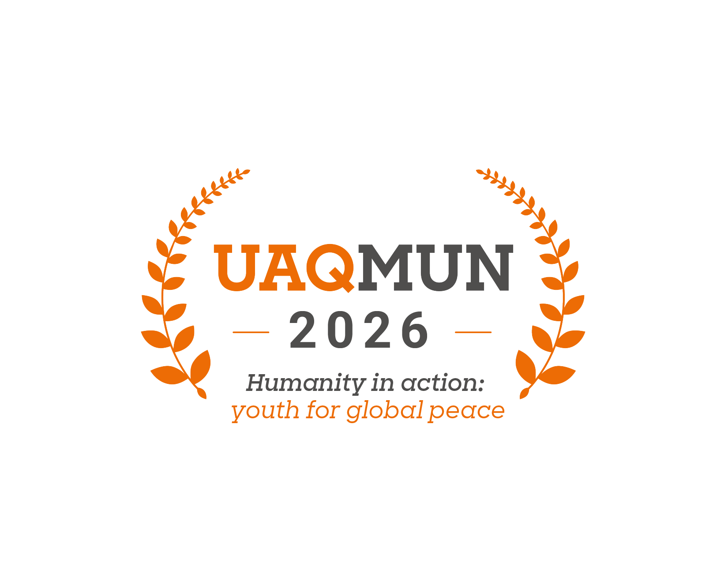

## **Introduction**

We are pleased to welcome you to this edition of the Model United Nations of Universidad Anáhuac Querétaro (UAQMUN 2026). The School of International Relations and the organizing team sincerely thank you for your participation, and we wish you a formative, challenging, and enriching experience within this model.

The United Nations Security Council (UNSC) is one of the six principal organs of the United Nations, entrusted with the primary responsibility of maintaining international peace and security. Established in 1945 under the UN Charter, the Security Council has a unique role in the international system, as it is the only UN body whose decisions are legally binding upon all Member States (United Nations, 1945). Its authority extends to authorizing military action, imposing sanctions, and establishing peacekeeping operations (United Nations, 2024). The Security Council is composed of fifteen members: five permanent members with veto power, the United States, the United Kingdom, France, Russia, and China, and ten non-permanent members elected by the General Assembly for two-year terms (United Nations, n.d.-b). This structure reflects both historical realities at the end of World War II and the ongoing balance of power in global governance. The veto power of the permanent members makes the Security Council one of the most influential yet sometimes controversial bodies of the UN system (Security Council Report, 2024).

The Security Council continues to be at the heart of international diplomacy, where the responsibility to protect, prevent conflict, and maintain peace converge, making it a cornerstone of the global governance system.

On this occasion, the committee will focus on the following debate:

***“The Global Weaponization of Energy: Sanctions, Pipelines, and the Use of Oil and Gas as Tools of War”***

The growing use of energy resources as tools of geopolitical influence has raised serious concerns for global stability. Oil and gas, vital for economies, are increasingly used in conflict, diplomacy, and coercion. Sanctions on energy exports and control over pipelines reshape international relations, heighten rivalries, and test the resilience of global markets. This raises pressing questions about energy security, sovereignty, and the ethics of using essential resources as leverage in crises.

Therefore, this committee invites delegates to examine the legal, political, and economic dimensions of energy weaponization, with particular attention to sanctions and their consequences. This background document offers a general overview to understand the historical precedents, present dynamics, and potential outcomes of this debate. It is expected that each delegate undertakes thorough research to represent faithfully the position of their country while proposing innovative solutions that balance energy security, fair access, and international stability.

Finally, we extend our recognition to every delegate for embracing this challenge. We hope that UAQMUN 2026 will not only serve as an academic exercise but also as an opportunity to reflect on the significance of negotiation, cooperation, and collective action in building a more secure and equitable world.

**Topic “B”: The Global Weaponization of Energy: Sanctions, Pipelines, and the Use of Oil and Gas as Tools of War**

Energy resources, particularly oil and gas, are central to modern economies and international relations. However, their strategic importance has also made them powerful tools of coercion in global conflicts. The “weaponization” of energy refers to the deliberate use of energy supplies and infrastructure, such as pipelines, exports, or sanctions, as instruments of political or military pressure. This phenomenon has shaped numerous conflicts in recent history, undermining global energy security and threatening the livelihoods of millions. For the United Nations Security Council, the regulation and monitoring of such practices are critical to ensuring that energy resources do not become catalysts of instability and war.

According to the International Energy Agency (IEA), disruptions in oil and gas supplies, whether due to sanctions, blockades, or deliberate cut-offs, can trigger sharp increases in global prices, disproportionately affecting vulnerable economies (IEA, 2022). The use of energy as a geopolitical weapon was most evident in the 1973 oil embargo, the Russia-Ukraine conflict beginning in 2014 and escalating in 2022, and recent tensions in the Middle East. These cases illustrate how pipelines and energy infrastructure have been turned into tools of leverage, destabilizing regions and creating humanitarian crises.

***Energy as a Geopolitical Weapon***

Energy dependency creates vulnerabilities that states can exploit during conflicts. For example, Russia’s suspension of gas exports to Europe during the 2022 invasion of Ukraine revealed the deep interconnection between energy security and military strategy (Northam, 2022). Similarly, historical embargoes such as the 1973 Arab oil embargo demonstrated the capacity of energy-exporting states to influence foreign policy decisions in consuming nations by restricting supply.

This dynamic has profound consequences for international stability, as energy-exporting states may gain disproportionate influence over energy-dependent countries. Moreover, the manipulation of energy markets exacerbates economic inequality, particularly for developing nations with limited resources to withstand price shocks.

### ***Sanctions, Blockades, and Humanitarian Impacts***

Sanctions and blockades targeting energy sectors are often employed as tools to pressure governments engaged in conflict or human rights violations. While sanctions can be effective in limiting revenues used to finance wars, they also carry unintended humanitarian consequences. A report by the United Nations Conference on Trade and Development (Simiyu et al., 2025) notes that energy sanctions often result in rising prices for electricity, heating, and transportation, disproportionately harming civilians.

The case of sanctions against Iran’s energy sector illustrates both the potential and limitations of such measures. While these sanctions reduced government revenues, they also led to severe economic contraction, shortages of essential goods, and increased poverty rates (World Bank, 2022). The challenge for the Security Council lies in designing sanctions that effectively target regimes without exacerbating humanitarian suffering.

### ***Pipelines, Infrastructure, and Security***

Energy infrastructure, such as pipelines, refineries, and shipping routes, has become a focal point of geopolitical competition. The Nord Stream pipelines, for instance, have been at the center of political disputes between Russia, the European Union, and NATO allies. Attacks on energy infrastructure—whether cyberattacks on pipeline networks or physical sabotage—pose additional threats to global energy security.

The International Renewable Energy Agency (IRENA, 2024) emphasizes that as long as global dependency on fossil fuels remains high, pipelines and energy corridors will continue to serve as both strategic assets and potential targets in conflicts. Protecting such infrastructure while diversifying energy sources is essential for reducing the risks associated with energy weaponization.

### ***Transition to Renewable Energy and Long-Term Solutions***

While fossil fuels remain central to the global economy, the transition to renewable energy provides a long-term solution to the vulnerabilities created by energy weaponization. By reducing reliance on imported oil and gas, countries can enhance their energy independence and resilience to external shocks. The UN’s Sustainable Development Goal 7 (Affordable and Clean Energy) and the Paris Agreement on climate change both highlight the urgency of shifting to renewable energy, not only for environmental sustainability but also for geopolitical stability (United Nations, 2015).

However, the transition will take time, and the Security Council must address immediate risks. This includes balancing the use of sanctions with humanitarian protections, promoting transparency in energy trade, and encouraging international cooperation to secure energy supplies during conflicts.

### ***Current Situation and UN Measures***

The United Nations has not established a specific framework to regulate the weaponization of energy. Nevertheless, the Security Council has repeatedly addressed issues related to sanctions on the oil and gas sectors, particularly in cases involving Iraq, Iran, Libya, and Russia. These precedents provide important lessons on the effectiveness and unintended consequences of such measures. Future resolutions may seek to introduce mechanisms that safeguard civilians from energy-related sanctions and promote the protection of critical infrastructure in conflict zones.

**Guiding questions**

1. How can the Security Council design sanctions that effectively limit the financing of wars without worsening humanitarian crises?
2. Should pipelines and energy infrastructure be granted special protection under international law, similar to cultural heritage sites or humanitarian assets?
3. How can countries diversify their energy supplies to reduce vulnerability to coercion?
4. What lessons can be learned from past cases of energy weaponization, such as the 1973 oil embargo or the Russia–Ukraine conflict?
5. To what extent should the Security Council promote renewable energy as part of its strategy to reduce future energy-related conflicts?
6. How can international cooperation be strengthened to protect critical energy infrastructure from attacks or sabotage?
7. What role should non-state actors (such as multinational corporations and civil society organizations) play in preventing the weaponization of energy?
8. How can the Security Council ensure that energy sanctions are enforced equitably across states with different economic dependencies and vulnerabilities?
9. What mechanisms can be implemented to monitor and verify compliance with energy-related sanctions and embargoes?
10. How can the UN balance the strategic interests of energy-exporting and energy-importing states to prevent escalations during conflicts?
11. In what ways can regional organizations (e.g., EU, OPEC, ASEAN) support the Security Council in mitigating energy coercion?
12. How can long-term investment in energy infrastructure and technology reduce the leverage of states seeking to weaponize energy?

**Member States**

1. United States
2. Russia
3. China
4. India
5. France
6. United Kingdom
7. Japan
8. Germany
9. South Korea
10. Australia
11. Canada
12. Israel
13. Turkey
14. Brazil
15. Italy
16. Mexico
17. Argentina
18. South Africa
19. Egypt
20. Nigeria
21. Ethiopia
22. Indonesia
23. Saudi Arabia
24. United Arab Emirates (UAE)
25. Iran
26. Poland
27. Ukraine
28. Pakistan
29. Kazakhstan
30. North Korea

**References**

International Energy Agency (IEA). (2022). *World Energy Outlook 2022*. IEA. <https://www.iea.org/reports/world-energy-outlook-2022>

International Renewable Energy Agency (IRENA). (2024). *GEOPOLITICS OF THE ENERGY TRANSITION ENERGY SECURITY*. IRENA. <https://www.apeg.pt/folder/documento/ficheiro/869_IRENA_Geopolitics_transition_energy_security_2024.pdf>

Northam, J. (2022). *Russia is using energy as a weapon. Could this spread to the rest of the world?* Npr. <https://www.npr.org/2022/11/02/1133667483/russia-is-using-energy-as-a-weapon-could-this-spread-to-the-rest-of-the-world>

Simiyu, Z., Oke, G., Evalistus, N., Shadrack, O., Israel, O., Opeoluwa, O., & Udim, O. (2025). Energy sanctions in the global economy: Geopolitical disruptions, market fragmentation, innovation and green transition. *International Journal of Innovation Studies*, *9*(3), 246–261. <https://www.sciencedirect.com/science/article/pii/S2096248725000268>

United Nations. (2015). *Sustainable Development Goal 7: Affordable and clean energy*. <https://sdgs.un.org/goals>

World Bank. (2022). *Iran Economic Monitor: Energy sanctions and economic impact*. <https://www.worldbank.org>