**Topic A: Unaccompanied migrant children: loss of parental protection in contexts of deportation and displacement**

UNHCR

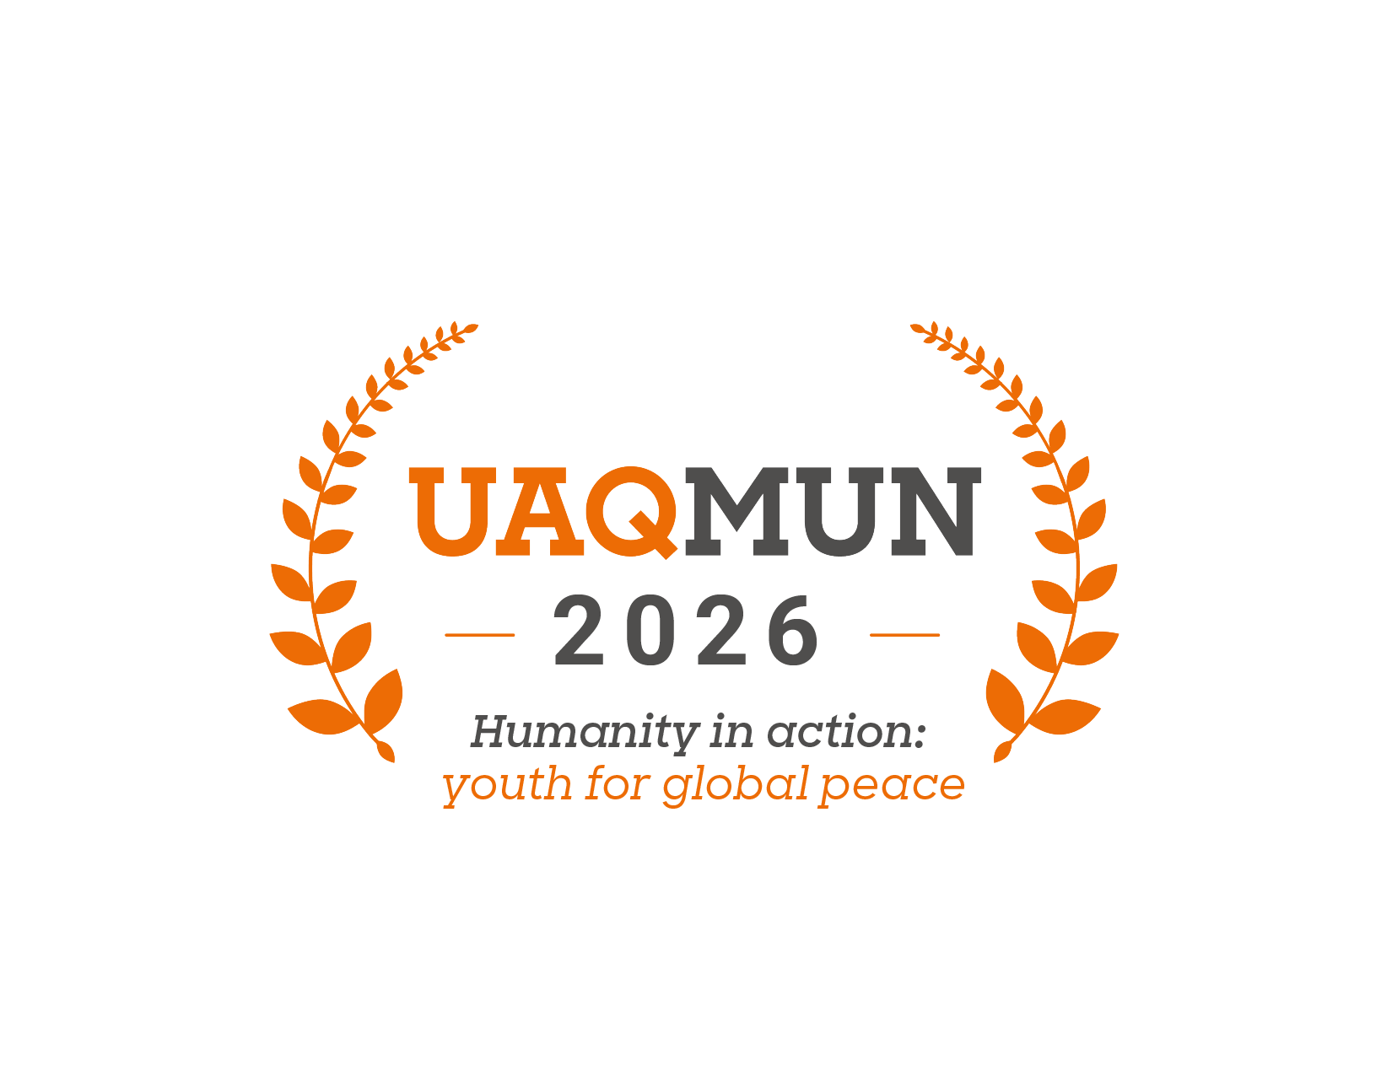

## **Introduction**

We are pleased to welcome you to this edition of the Anahuac Querétaro University Model United Nations (UAQMUN 2026). The School of International Relations and the organizing team sincerely appreciate your participation and wish you a formative, challenging, and enriching experience within this model.

The United Nations High Commissioner for Refugees (UNHCR), also known as the Refugee Agency, is a principal body of the United Nations system dedicated to the protection and assistance of refugees, asylum seekers, stateless persons, and internally displaced populations worldwide. Established in 1950, following the aftermath of the Second World War, the UNHCR has since carried the mandate to safeguard the rights and well-being of those forced to flee their homes due to persecution, armed conflict, or violence (UNHCR, n.d.). This committee plays a vital role in coordinating international action to ensure access to asylum, promote durable solutions, and uphold the principle of non-refoulement. It works in close cooperation with Member States, non-governmental organizations, and other UN agencies to provide shelter, legal protection, humanitarian assistance, and long-term integration strategies (UNHCR, n.d.). In this forum, we aim to address pressing challenges affecting displaced populations, fostering international solidarity and shared responsibility.

To commence, we would like to introduce the committee, in which the discussion topic will be the following:

***“Unaccompanied migrant children: loss of parental protection in contexts of deportation and displacement”***

This issue highlights one of the most vulnerable groups within migration flows. Unaccompanied children face heightened risks of exploitation, trafficking, violence, and violations of their fundamental rights. Deportation processes and forced displacement often leave minors without parental protection, raising urgent ethical, humanitarian, and legal concerns for the international community.

Therefore, this committee invites delegates to analyze the root causes of child migration, the policies implemented by states, and the challenges of international coordination to guarantee the protection of minors. This background document offers a general overview to understand the dynamics and consequences of this problem.

It is expected that each delegate conducts rigorous research to accurately reflect their country’s position while proposing realistic and humane solutions that strengthen international cooperation and safeguard the rights of unaccompanied migrant children.

Finally, we extend our recognition to every delegate for taking on this challenge. We hope that UAQMUN 2026 will not only be an academic exercise, but also an opportunity to reflect on the importance of dialogue, negotiation, and collective action in building a safer and more just world for displaced children.

**Topic “A”: Unaccompanied migrant children: loss of parental protection in contexts of deportation and displacement**

*“*Migration and displacement are urgent global issues, fuelled by challenges that include political instability, conflict, climate change, natural disasters, and the need to find better economic opportunities*”* (UNICEF, 2024).

Migration can be defined as the movement of people away from their place of origin to a new place of residence, either across international borders or within a State (IOM, 2024). Moreover, each year the number of migrants increases, with around 281 million people, including children, leaving or being forcibly displaced from their homes to seek safety, better opportunities, and a greater quality of life (UNICEF, 2024).

In this context, displacement and migration affect children across the World in different ways, being a recognized part of today's global migration flows and therefore becoming a new area of concern and focus. Within this frame, the international community is alarmed about the children and adolescents who are often met with inadequate reception facilities, complex bureaucratic procedures, lack of access to services and basic needs (including health and education), discrimination and insecurity, with the possibility of falling into the hands of trafficking, and finally, the constant fear of being returned (UNICEF, 2024).

As previously stated, the embarkation of this journey is dangerous and often fatal, and these children may be accompanied by their parents, guardians, or other adults. But there is also a group of unaccompanied migrant children. As defined by the Convention on the Rights of the Child (CRC), an unaccompanied minor (UAM) is “*a child or adolescent under the age of 18, who is separated from both parents and other relatives and is not being cared for by any other adult who, by law or custom, is responsible for doing so*”. Moreover, it is important to distinguish between UAM and separated children, who, as described in Article 1 of the CRC, may have been separated from both parents or primary caregivers, but not necessarily from other relatives (Chavez & Menjívar, 2010; IOM, 2011).

Concerningly, the number of this segment of children is increasing; UNICEF estimated 36 million migrant children in the world in 2020, from which around 23,500 UAM arrived in Southern European countries, and another 137,000 UAM arrived in Mexico. Plus, this group is diverse, adding a potential risk of harm to health and integrity in the short and long term impact, especially to female, disabled, or identified as LGBTQ+ minors, due to the lack of protection of a family. And finally, the pandemic brought additional vulnerabilities for migrant children, including: an increase in the number of children returning to their countries of origin, aggravating conditions in shelters and detention centers, border closures, increased xenophobia and discrimination (Chavez & Menjívar, 2010; IOM, 2011)

***History of the topic***

Historically, research on migration was primarily focused on the male experience, and it was not until the mid-1960s that women, too, became a topic of interest. Moreover, recent research on migrant children and their diverse experiences has shown that they are active social agents who participate in adult-like activities and make economic and social contributions, such as when unaccompanied migrant teenagers find the necessity of full-time employment (Chavez & Menjívar, 2010). However, not every UAM experience is bound to be negative. Recent research reveals that children can be actively involved in the decision-making process regarding their future, especially when they encounter poverty, extreme weather events, hunger, unhealthy living conditions, lack of health and education services, military or gang recruitment, conflict, violence, and abuse in their home countries (Corona et al., 2021; IOM, 2011).

In line with the increasing attention focused on child migration as part of a larger phenomenon, it is of major importance to strengthen and support coherent approaches to UAM.

Regarding the protection of unaccompanied minors and separated children, there are many legal instruments that state parties must adhere to. Starting with the CRC, which is the first comprehensive and binding international legal tool to address children’s rights, including special measures to protect children from exploitation, torture, and any other form of degrading treatment.

“The CRC also states that children must be 'protected against all forms of discrimination or punishment on the basis of the status, activities, expressed opinions or beliefs' of their parents, legal guardians, or family members” (Radjenovic, 2024)

In this context, these obligations of the state parties from the CRC apply not only to the children within the borders of a state, but also to those who come under the state's jurisdiction while attempting to enter its territory. This means that the rights stipulated in the CRC are available to all children, including the cases of asylum-seeking, refugee, and migrant children, regardless of their nationality, immigration status, or statelessness.

***Discussion of the topic:***

As previously stated, there are many vulnerabilities that UAM and separated children face, impacting them with a broad range of human rights challenges. For example, there is an extensive criminalization of irregular migrants, including children. In consequence, their human rights face restrictions, especially in those countries that require registration with a government authority as a requirement to access public services. Also, the lack of information and guidance may become a difficulty for migrant children when trying to access those basic services (Radjenovic, 2024).

Moreover, there is a global trend with increasing intolerance towards immigrants, fueled by economic anxieties, perceived threats to cultural and national identity, right-wing political rhetoric, and misinformation. This xenophobia manifests in certain current administrations around the world that are taking harsher policies to regulate the flow of immigrants that they receive. To illustrate it, the U.S under President Trump’s first administration, adopted a “zero tolerance” policy in April 2018, under which the department of Homeland Security (DHS) separated more than 2000 children from their parents at the border during the period of mid-April to June, placing the children in shelters and onto the foster system (American Bar Association, 2018).

In this context, countries need to operate in the best interests of migrant children, with a special focus on UAM; also, receptor countries must design frameworks that avoid family disintegration.

Following this line, there are many international organizations that are making a constant effort to face these challenges. For example, IOM’s activities include the implementation of family tracing and direct support towards family reunification, assisted voluntary return and reintegration, assistance for UAM in transit and destination countries to ensure adequate reception and integration, among many others (IOM, 2011).

Finally, UNHCR urgently calls for action for the creation of an overall protection framework that guides all decisions on behalf of UAM and separated children. The international actors concerned must ensure that the policies, programmes, and decisions are carried out impartially, fully coordinated, and adhere to the corresponding instruments of international humanitarian law.

**Guiding questions**

1. What are the main factors that force children to migrate unaccompanied (conflict, poverty, climate change, violence, etc.)?
2. In what ways do deportation policies contribute to the family separation of migrant children? Should they be adapted to ensure the best interests of children?
3. What role should receiving states play in ensuring access to education, healthcare, and basic services for UAM?
4. How have xenophobia and restrictive migration policy (e.g., U.S. “zero tolerance” policy) impacted the rights and safety of migrant children?
5. What are the particular vulnerabilities faced by girls, children with disabilities, and LGBTQ+ minors in the context of unaccompanied migration?
6. How can organizations such as UNICEF, UNHCR, and IOM cooperate with state members to strengthen protection frameworks for UAM?
7. What long-term solutions (e.g., family reunification, local integration, resettlement) should be prioritized to address the challenges faced by unaccompanied migrant children?
8. Should unaccompanied migrant children be granted a special international legal status that guarantees stronger protection than current refugee or asylum frameworks?
9. How can states balance border control and national security with their obligation to protect the best interests of the child?
10. What role should regional agreements (e.g., EU, MERCOSUR, African Union) play in ensuring cross-border protection of unaccompanied minors?
11. Should family reunification always be prioritized over alternative solutions such as foster care or community-based integration programs?

**Member States**

1. United States of America
2. Mexico
3. Canada
4. Brazil
5. Argentina
6. Colombia
7. Venezuela
8. Honduras
9. El Salvador
10. Guatemala
11. Haiti
12. United Kingdom
13. France
14. Germany
15. Spain
16. Italy
17. Greece
18. Turkey
19. Russia
20. Ukraine
21. Nigeria
22. Democratic Republic of the Congo
23. South Africa
24. Ethiopia
25. Kenya
26. Bangladesh
27. India
28. Pakistan
29. China
30. Philippines

**References**

American Bar Association. (2018). *Family Separation and Detention*. Americanbar.org. <https://www.americanbar.org/advocacy/governmental_legislative_work/priorities_policy/immigration/familyseparation/>

Chavez, L., & Menjívar, C. (2017). Children without Borders: A Mapping of the Literature on Unaccompanied Migrant Children to the United States. *Migraciones Internacionales, 5(18)*, 71–111. <https://doi.org/10.17428/rmi.v5i18.1080>

Corona Maioli S, Bhabha J, Wickramage K, Wood LCN, Erragne L, Ortega García O, Burgess R, Digidiki V, Aldridge RW, Devakumar D. International migration of unaccompanied minors: trends, health risks, and legal protection. *Lancet Child Adolesc Health. 2021 Dec;5(12):*882-895. doi: 10.1016/S2352-4642(21)00194-2. Epub 2021 Aug 18. PMID: 34416189; PMCID: PMC7615140. <https://www.thelancet.com/journals/lanchi/article/PIIS2352-4642(21)00194-2/fulltext>

IOM. (2011). *Unaccompanied Children on the Move The work of the International Organization for Migration (IOM)*. <https://www.iom.int/sites/g/files/tmzbdl486/files/jahia/webdav/site/myjahiasite/shared/shared/mainsite/events/docs/Unaccompanied_children.pdf>

IOM. (2024). *Fundamentals of migration. International Organization for Migration*. <https://www.iom.int/fundamentals-migration#:~:text=Most%20international%20migrants%20move%20for,sometimes%20called%20%E2%80%9Cinternal%20migrants%E2%80%9D>

UNHCR. (2004). *Inter-agency Guiding Principles on UNACCOMPANIED and SEPARATED CHILDREN*. UNHCR. <https://www.unhcr.org/sites/default/files/legacy-pdf/4098b3172.pdf>

Radjenovic, A. (2024). *Vulnerability of unaccompanied and separated child migrants*. EPRS | European Parliamentary Research Service. <https://www.europarl.europa.eu/RegData/etudes/BRIE/2024/762339/EPRS_BRI(2024)762339_EN.pdf>

UNICEF. (2024). *In Focus: Protecting children affected by migration and forced displacement Ensuring safety and support for every child in Europe and Central Asia*. <https://www.unicef.org/eca/media/37391/file/In%20Focus%20Protecting%20children%20affected%20by%20migration%20and%20forced%20displacement.pdf>