**Topic B: Forced displacement due to climate disasters: international recognition and protection for environmental migrants**

UNHCR

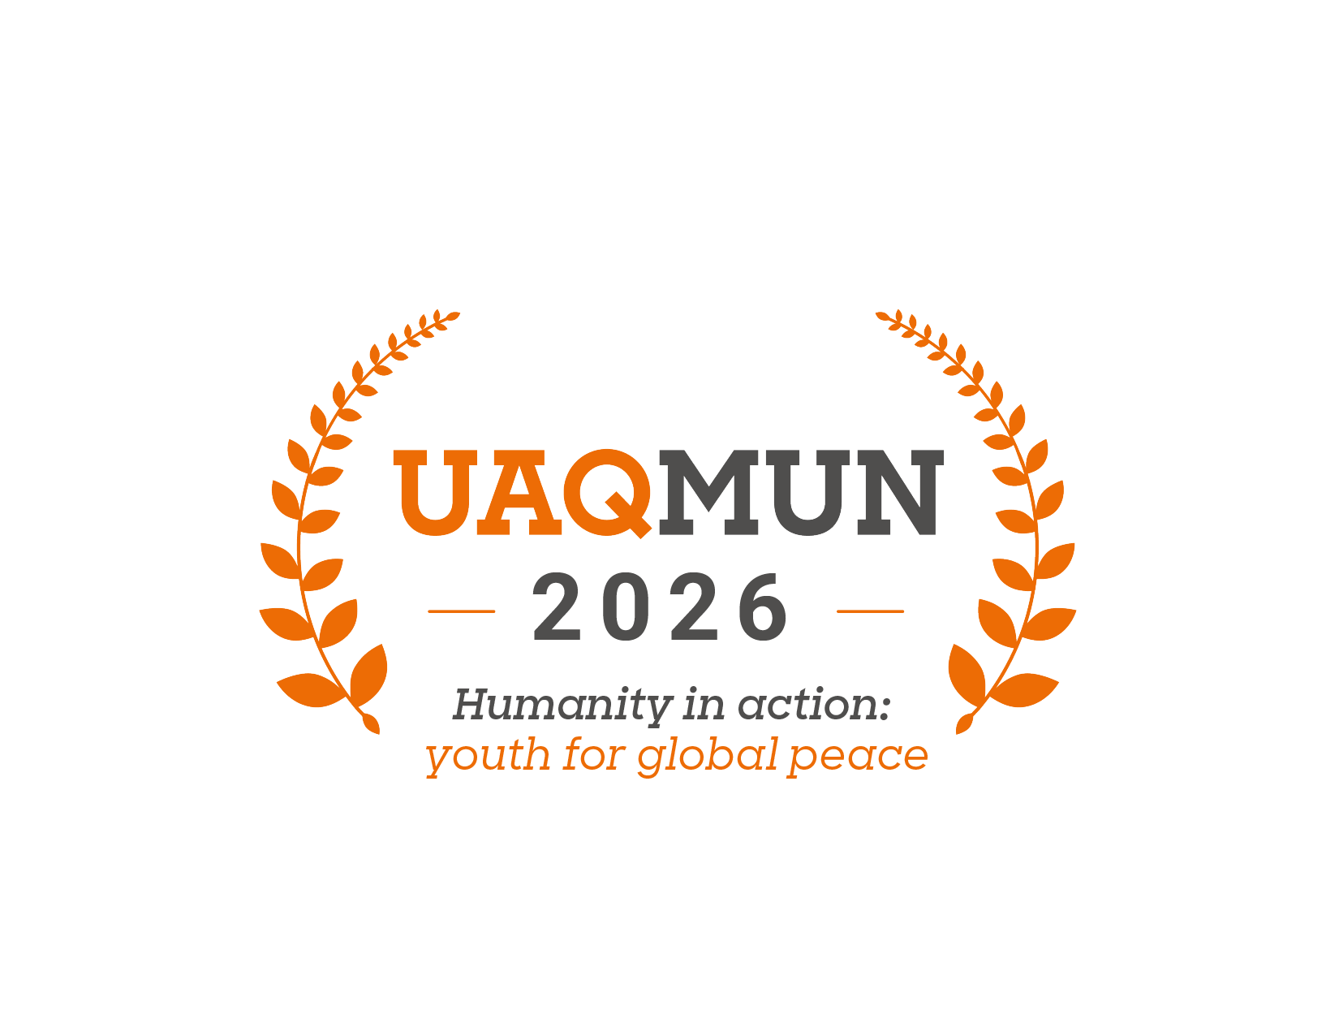

## **Introduction**

We are pleased to welcome you to this edition of the Anahuac Querétaro University Model United Nations (UAQMUN 2026). The School of International Relations and the organizing team sincerely appreciate your participation and wish you a formative, challenging, and enriching experience within this model.

The United Nations High Commissioner for Refugees (UNHCR), also known as the Refugee Agency, is a principal body of the United Nations system dedicated to the protection and assistance of refugees, asylum seekers, stateless persons, and internally displaced populations worldwide. Established in 1950, following the aftermath of the Second World War, the UNHCR has since carried the mandate to safeguard the rights and well-being of those forced to flee their homes due to persecution, armed conflict, or violence (UNHCR, n.d.). This committee plays a vital role in coordinating international action to ensure access to asylum, promote durable solutions, and uphold the principle of non-refoulement. It works in close cooperation with Member States, non-governmental organizations, and other UN agencies to provide shelter, legal protection, humanitarian assistance, and long-term integration strategies (UNHCR, n.d.). In this forum, we aim to address pressing challenges affecting displaced populations, fostering international solidarity and shared responsibility.

To commence, we would like to introduce the committee, in which the discussion topic will be the following:

***“Forced displacement due to climate disasters: international recognition and protection for environmental migrants”***

This topic highlights the growing link between climate change and human mobility, raising questions about the adequacy of current legal frameworks and the responsibilities of the international community toward people displaced by rising sea levels, extreme weather events, and desertification. Unlike refugees fleeing persecution or war, environmental migrants often fall outside existing protection systems, leaving legal and humanitarian gaps that demand innovative and collaborative solutions.

Therefore, delegates are invited to analyze the challenges of recognizing and protecting environmental migrants, reviewing existing policies, regional initiatives, and possible reforms to international law. This background document provides a general overview to guide research and support critical debate on this urgent issue.

We expect each delegate to conduct rigorous research to reflect their country’s position and propose realistic solutions that integrate humanitarian assistance, human rights, and sustainable development.

**Topic “B”: Forced displacement due to climate disasters: international recognition and protection for environmental migrants.**

## *“The climate crisis is amplifying displacement and making life harder for those already forced to flee” (UNHCR, 2024).*

Climate change and displacement have become increasingly interconnected. The study of the relationship between the two topics has led to the conclusion that, as a consequence of climate change, living conditions in some parts of the world have turned extremely complicated, especially in relation to water shortage and turbulent weather conditions, causing loss of livelihood, employment, lands, infrastructure, violence, and conflict, as well as making many places uninhabitable and therefore, enhancing forced migration (Arenilla & Rada, 2020).

Climate migration is no longer a distant concern, unfolding as a silent and multidimensional crisis that presses the reality and demands immediate action. It refers to the movement of individuals or communities compelled to leave their place of origin due to environmental changes caused or exacerbated by climate change. Moreover, recent disasters such as hurricanes, floods, and wildfires have displaced millions of people; according to the International Organization for Migration (IOM), over the past decade, more than 218 million internal displacements have taken place as a consequence of weather-related disasters (Omolere, 2052).

Other implications related to climate change, such as desertification and rising sea levels, have forced communities to migrate due to unsustainable conditions in their livelihoods. Also, resource scarcity has been exacerbated, leading to competition for water and arable land, increasing conflicts, violence, and further resulting in migration. And, environmental degradation often impacts the economy as well, pushing people to move in search of better opportunities (Omolere, 2025).

It is no surprise that the international community is concerned about the coming years and the millions of people who will be forced from their homes as a consequence of the climate crisis. By the end of 2023, 75.9 million people were living in internal displacement, and 7.7 million of them were displaced due to disasters. This illustrates that climate migration is not a future problem, and is already happening and intensifying alongside climate change. It is estimated that by 2050, more than 170 million people will be displaced as a result of slow-onset climate impacts. Also, the World Bank’s 2021 Groundswell Report projects that if global warming continues unabated, by 2050, over 216 million people will become internal climate migrants across six regions: Sub-Saharan Africa, South Asia, East Asia and Pacific, North Africa, Latin America, Eastern Europe, and Central Asia (Omolere, 2025).

Currently, climate migration occurs mostly within national borders, where rural populations are forced to move to urban centers due to flooding and salinity intrusion. However, cross-border movements are increasing, especially in Central America, where droughts have driven migration towards the U.S. Also, it is expected that in a few years, the Pacific Islands will face permanent displacement due to rising sea levels, and arid regions in Africa will see increased migrations as a result of desertification and water scarcity (Omolere, 2025).

Although it is thought that the climate crisis only enhances migration, it also exacerbates conditions for further forced displacement. The majority of people forcibly displaced by persecution, conflict, and violence are prone to live in countries that nowadays are highly vulnerable and unprepared to adapt to climate change. Also, displaced populations often lack options regarding their living conditions, having limited access to basic services and being exposed to climate hazards like floods, drought, storms, and heatwaves (UNHCR, 2025).

As a response to the climate crisis, UNHCR has built a *Strategic Framework for Climate Action* that details the *Strategic Plan for Climate Action 2024-2030*, a guideline meant to support governments through prioritized action and a wide range of partners with a main goal:

“That by 2030, increasing numbers of forcibly displaced and stateless people fleeing from climate-fueled crises and/or living in climate-vulnerable countries find solutions, are protected and resilient to the impacts of climate change, and have the means to live self-sufficient lives”(UNHCR, 2025, para. 7).

***History of the topic***

The impact of the climate crisis on human mobility has been studied for nearly half a century, but until two decades ago, the IOM was requested by its members to recognize and take up the issue of climate migration (Aleinikoff, 2024).

So, as previously stated, climate change has taken over the international agenda in the last few decades, becoming one of the most important and controversial topics of discussion among scientists, governments, and international organizations, evaluating the potentially threatening consequences that this phenomenon entails. In this regard, the United Nations has addressed this issue since the first World Climate Conference in 1979. Nevertheless, it was not until recent years that it was included in the 2030 Agenda for Sustainable Development, where Goal 13 urges to *“[…] take urgent action to combat climate change and its impacts”* (Arenilla & Rada, 2020).

Also, in 2015, the UN General Assembly recognized that the consequences of climate change are circumstances that affect all nations, especially the developing countries that live in vulnerable conditions. This same year, the first international agreement on climate change was negotiated and signed, as a result of the Paris Climate Conference (COP21), where 195 countries adopted the first universal, legally binding global climate deal, the Paris Agreement, which acknowledges that:

“[...] climate change is a common concern of humankind, Parties should, when taking action to address climate change, respect, promote and consider their respective obligations on human rights, the right to health, the rights of indigenous peoples, local communities, migrants, children, persons with disabilities and people in vulnerable situations and the right to development, as well as gender equality, empowerment of women and intergenerational equity” (Arenilla & Rada, 2020, para. 3)

However, climate migration, per se, received attention until the Global Compact for Migration (GCM), supporting a more expansive approach and stressing participant states *“the necessity to step up national, regional and international efforts to address human mobility challenges associated with environmental factors and climate change”* (Aleinikoff, 2024).

***Discussion of the topic***

The international community has devoted little attention to climate migration, and as it is a multidimensional phenomenon, it has to be approached with different perspectives (climate change, migration, human rights, development), recognizing that those affected merit assistance and protection. Nevertheless, what is lacking in the global conversation is a conceptual framework for policy and a structure for effective climate action, given that the existing international refugee regime does not protect those affected by climate displacement (Aleinikoff, 2024).

Building a new legal framework to address climate migration, in which there is recognition of a new category of persons worthy of international protection or finding legal protection for environmentally displaced people within the international refugee law framework, has been proven extremely difficult(Arenilla & Rada, 2020).

In essence, individuals displaced by climate-related factors do not qualify as refugees *stricto sensu*, but they may nonetheless be entitled to international protection. In that line, the UN Human Rights Committee (HRC) recognized in Teitiota v. New Zealand that the negative consequences of climate change *“may expose individuals to a violation of their rights under the International Covenant on Civil and Political Rights (ICCPR), thereby triggering non-refoulement obligations”* in specific situations. This symbolized an important step toward integrating environmental displacement into the framework of international human rights law. The Committee did not, however, categorize those escaping climate-related hardship as "refugees" in the sense of the 1951 Refugee Convention and its 1967 Protocol. The ruling highlights the insufficiency of current legal tools to adequately address the complex nature of such movement, while also reflecting the rise of a human rights-based approach to climate-induced displacement (Caligiuri, 2025).

It is also important to note that under international refugee law, the 1952 Convention on the Status of Refugees and the 1967 Protocol Relating to the Status of Refugees describe the concept of refugee very restrictively, especially considering that States often establish policies to keep refugees outside their jurisdiction. Consequently, it does not include people in need of protection beyond those who fear being persecuted because of their race, religion, nationality, or membership in a particular group. As a result, there have been calls for a new international instrument to be adopted that addresses climate and environmental displacement, and, even though there are critics who argue that such initiatives are politically unfeasible, without legal recognition, climate migrants remain dependent on *ad hoc* national policies and discretionary measures (Caligiuri, 2025).

**Guiding questions**

1. Should environmental migrants be granted a new legal status under international law, distinct from refugees and internally displaced persons?
2. To what extent can the 1951 Refugee Convention be expanded or reinterpreted to include climate-induced displacement?
3. What role should UNHCR play in coordinating international responses to climate displacement, given its current mandate?
4. How can states balance national sovereignty with the need to protect individuals displaced by climate disasters?
5. Should climate-displaced persons have a right to cross borders legally and seek asylum or protection?
6. How can the principle of non-refoulement be applied to individuals fleeing life-threatening climate disasters?
7. What regional frameworks (e.g., African Union, Pacific Islands Forum, OAS) could serve as models for addressing climate-induced migration?
8. Should a new international treaty be negotiated to recognize and protect climate migrants, or is it better to strengthen existing mechanisms?
9. How can international funding be mobilized to support states most affected by climate displacement, especially small island nations and Sub-Saharan Africa?
10. What role can the Paris Agreement and climate finance mechanisms play in addressing displacement caused by environmental change?
11. How should the international community address planned relocation and resettlement for communities facing permanent loss of territory due to rising sea levels?
12. In what ways can technology and data collection improve early warning systems and preparedness to reduce forced displacement?
13. How can cooperation between humanitarian and development actors be strengthened to provide both immediate relief and long-term resilience for displaced populations?
14. What obligations should developed countries have in supporting climate-displaced populations, considering their historical contribution to global warming?
15. How can the rights of vulnerable groups (children, women, indigenous peoples) be safeguarded within the framework of climate-related displacement?

**Member States**

1. United States of America
2. Mexico
3. Canada
4. Brazil
5. Argentina
6. Colombia
7. Venezuela
8. Honduras
9. El Salvador
10. Guatemala
11. Haiti
12. United Kingdom
13. France
14. Germany
15. Spain
16. Italy
17. Greece
18. Turkey
19. Russia
20. Ukraine
21. Nigeria
22. Democratic Republic of the Congo
23. South Africa
24. Ethiopia
25. Kenya
26. Bangladesh
27. India
28. Pakistan
29. China
30. Philippines

**References**

Aleinikoff, T. A. (2024). Climate-Induced Displacement and the International Protection of Forced Migrants. Social Research: *An International Quarterly, 91(2)*, 421–444. <https://doi.org/10.1353/sor.2024.a930749>

Arenilla, S. L., & Rada, C. H. (2020). Climate Change and Forced Migration. *Migraciones Internacionales, 11,* 1–20. <https://doi.org/10.33679/rmi.v1i1.1846>

Caligiuri, A. (2025). *Invisible in Law: Environmental and Climate Migrants and the Gap in International Protection.* Questions of International Law. <https://www.qil-qdi.org/invisible-in-law-environmental-and-climate-migrants-and-the-gap-in-international-protection/>

Omolere, M. P. (2025). *What Is Climate Migration and How Is the World Addressing It?* Earth.org. <https://earth.org/climate-migration-a-multidimensional-challenge-requiring-global-action/>

UNHCR. (2024). *Climate change and displacement | UNHCR*. <https://www.unhcr.org/what-we-do/build-better-futures/climate-change-and-displacement>

‌